#Date : 31/07/2026 #DT Batch 3
#Sahil Tagade #44
#12410016

# Implement forward propagation and backpropagation using TensorFlow/Keras. Analyze the #effect of different learning rates and the number of epochs on model performance.

import numpy as np import pandas as pd

import matplotlib.pyplot as plt import seaborn as sns

#wine dataset
from sklearn.datasets import load_wine

from sklearn.model_selection import train_test_split from sklearn.preprocessing import StandardScaler
from sklearn.metrics import ( confusion_matrix,
classification_report, accuracy_score
)

import tensorflow as tf

from tensorflow.keras.models import Sequential from tensorflow.keras.layers import Dense
from tensorflow.keras.optimizers import Adam

import warnings
warnings.filterwarnings("ignore")

print("Libraries Imported Successfully!") Libraries Imported Successfully!
wine = load_wine()

X = wine.data

y = wine.target

print("Wine Dataset Loaded Successfully!") Wine Dataset Loaded Successfully!
df = pd.DataFrame( X,
columns=wine.feature_names
)

df["Wine Class"] = y

print("First 5 Rows of Dataset") df.head()

First 5 Rows of Dataset

alcohol | malic_acid | ash | alcalinity_of_ash | magnesium | total_phenols | flavanoids | nonflavanoid_phenols | proanthocyanins | col
0 14.23 | 1.71 | 2.43 | 15.6 | 127.0 | 2.80 | 3.06 | 0.28 | 2.29
1 13.20 | 1.78 | 2.14 | 11.2 | 100.0 | 2.65 | 2.76 | 0.26 | 1.28
2 13.16 | 2.36 | 2.67 | 18.6 | 101.0 | 2.80 | 3.24 | 0.30 | 2.81
3 14.37 | 1.95 | 2.50 | 16.8 | 113.0 | 3.85 | 3.49 | 0.24 | 2.18
4 13.24 | 2.59 | 2.87 | 21.0 | 118.0 | 2.80 | 2.69 | 0.39 | 1.82

print("Shape of Dataset") print(df.shape)

print("\n")

print("Column Names") print(df.columns)
print("\n")

print("Dataset Information") df.info()
Shape of Dataset
(178, 14)

Column Names
Index(['alcohol', 'malic_acid', 'ash', 'alcalinity_of_ash', 'magnesium', 'total_phenols', 'flavanoids', 'nonflavanoid_phenols',
'proanthocyanins', 'color_intensity', 'hue',
'od280/od315_of_diluted_wines', 'proline', 'Wine Class'], dtype='object')

Dataset Information
<class 'pandas.core.frame.DataFrame'> RangeIndex: 178 entries, 0 to 177
Data columns (total 14 columns):
# |  | Column | Non-Null Count |  | Dtype
0 |  | alcohol | 178 non-null |  | float64
1 |  | malic_acid | 178 non-null |  | float64
2 |  | ash | 178 non-null |  | float64
3 |  | alcalinity_of_ash | 178 non-null |  | float64
4 |  | magnesium | 178 non-null |  | float64
5 |  | total_phenols | 178 non-null |  | float64
6 |  | flavanoids | 178 non-null |  | float64
7 |  | nonflavanoid_phenols | 178 non-null |  | float64
8 |  | proanthocyanins | 178 non-null |  | float64
9 |  | color_intensity | 178 non-null |  | float64
10 |  | hue | 178 non-null |  | float64
11 |  | od280/od315_of_diluted_wines | 178 non-null |  | float64
12 |  | proline | 178 non-null |  | float64
13 |  | Wine Class | 178 non-null |  | int64
dtypes: float64(13), int64(1) memory usage: 19.6 KB

df.describe()

 | alcohol | malic_acid | ash | alcalinity_of_ash | magnesium | total_phenols | flavanoids | nonflavanoid_phenols | proanth
count | 178.000000 | 178.000000 | 178.000000 | 178.000000 | 178.000000 | 178.000000 | 178.000000 | 178.000000 | 1
mean | 13.000618 | 2.336348 | 2.366517 | 19.494944 | 99.741573 | 2.295112 | 2.029270 | 0.361854
std | 0.811827 | 1.117146 | 0.274344 | 3.339564 | 14.282484 | 0.625851 | 0.998859 | 0.124453
min | 11.030000 | 0.740000 | 1.360000 | 10.600000 | 70.000000 | 0.980000 | 0.340000 | 0.130000
25% | 12.362500 | 1.602500 | 2.210000 | 17.200000 | 88.000000 | 1.742500 | 1.205000 | 0.270000
50% | 13.050000 | 1.865000 | 2.360000 | 19.500000 | 98.000000 | 2.355000 | 2.135000 | 0.340000
75% | 13.677500 | 3.082500 | 2.557500 | 21.500000 | 107.000000 | 2.800000 | 2.875000 | 0.437500
max | 14.830000 | 5.800000 | 3.230000 | 30.000000 | 162.000000 | 3.880000 | 5.080000 | 0.660000

print("Missing Values") print(df.isnull().sum()) print("\n")
print("Duplicate Rows")

print(df.duplicated().sum())

Missing Values
alcohol 0
malic_acid 0
ash 0
alcalinity_of_ash 0
magnesium 0
total_phenols 0
flavanoids 0
nonflavanoid_phenols 0
proanthocyanins 0
color_intensity 0
hue 0
od280/od315_of_diluted_wines 0
proline 0
Wine Class 0
dtype: int64

Duplicate Rows 0
plt.figure(figsize=(7,5)) sns.countplot(
x="Wine Class", data=df
)

plt.title("Distribution of Wine Classes") plt.xlabel("Wine Class")
plt.ylabel("Count") plt.show()

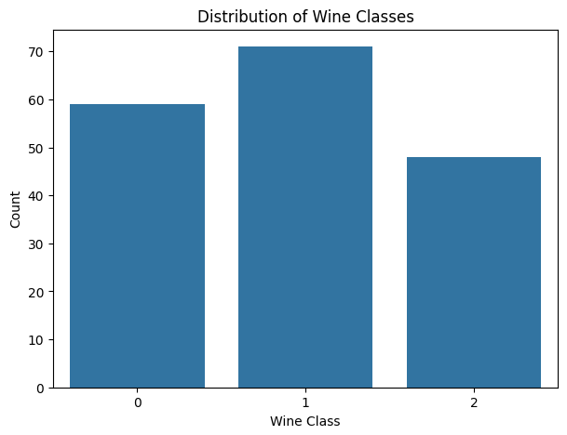

df.hist(
figsize=(16,12), bins=15,
edgecolor='black'
)

plt.suptitle("Distribution of Wine Dataset Features") plt.show()

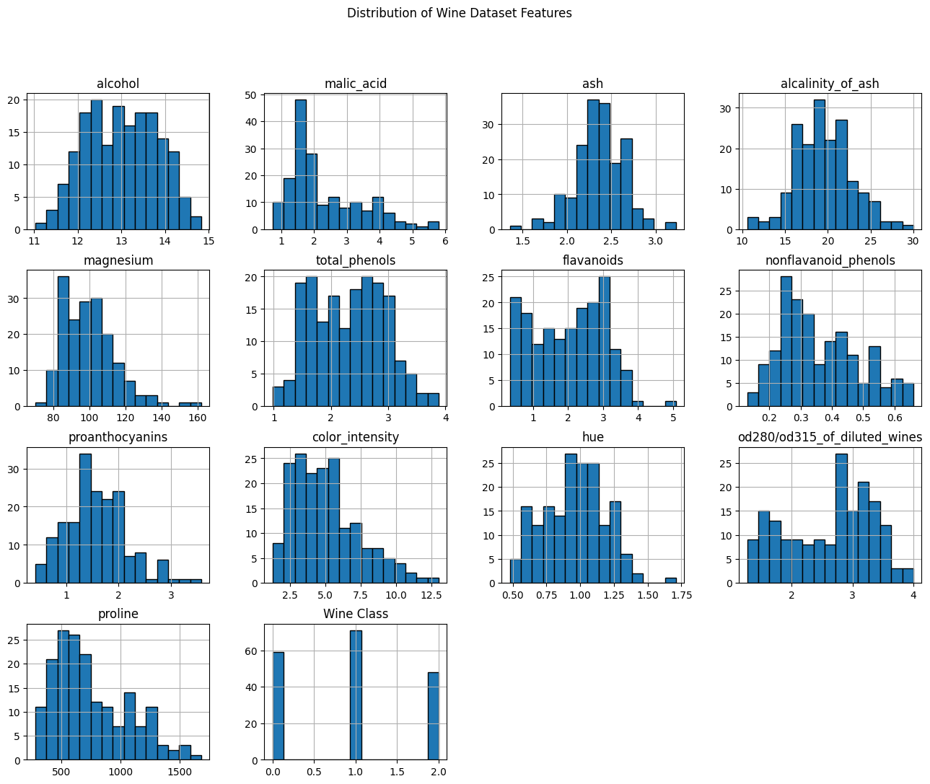

plt.figure(figsize=(15,6))

sns.boxplot(data=df.iloc[:, :-1]) plt.xticks(rotation=90)
plt.title("Box Plot of Wine Features") plt.show()

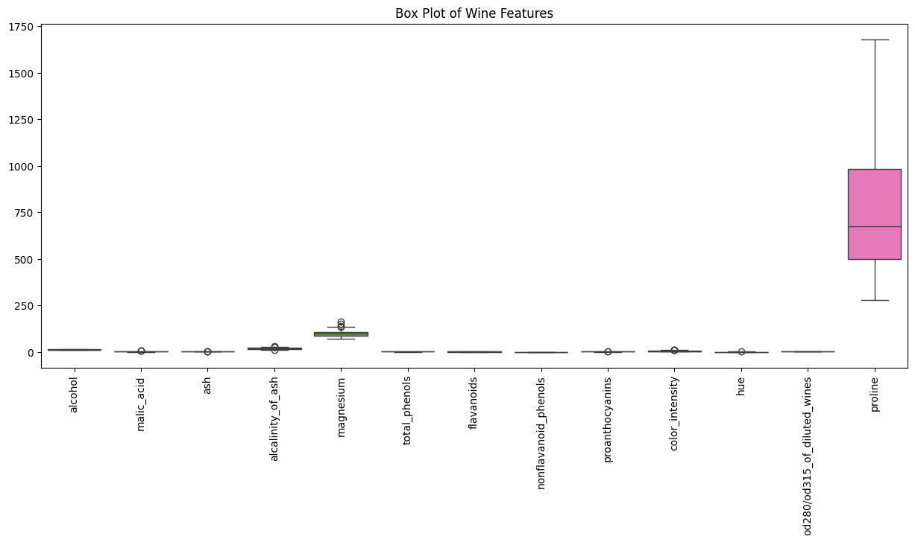

plt.figure(figsize=(12,10)) corr = df.iloc[:, :-1].corr() sns.heatmap(
corr,
annot=True,
cmap="coolwarm", linewidths=0.5
)

plt.title("Correlation Heatmap") plt.show()

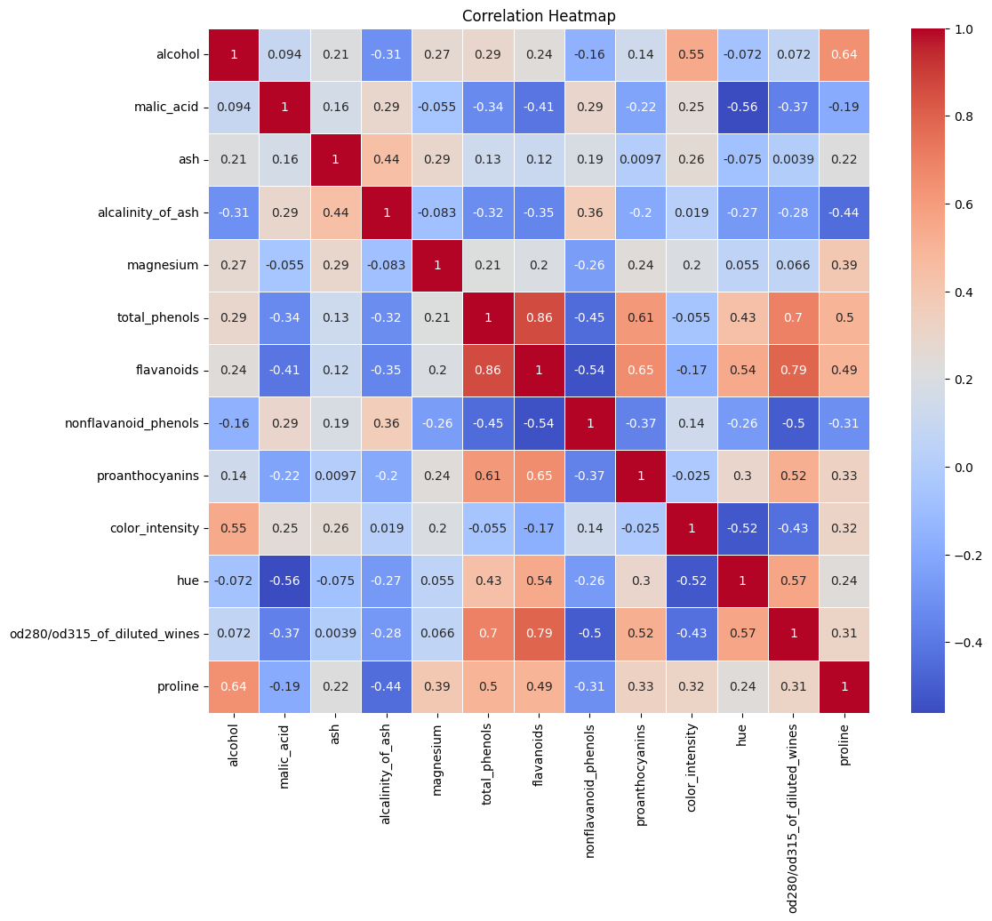

# Features
X = df.drop("Wine Class", axis=1)

# Target
y = df["Wine Class"]

print("Features Shape :", X.shape) print("Target Shape :", y.shape)

Features Shape : (178, 13) Target Shape : (178,)

X_train, X_test, y_train, y_test = train_test_split( X,
y,
test_size=0.20, random_state=42, stratify=y

)

print("Training Samples :", X_train.shape[0]) print("Testing Samples :", X_test.shape[0])
Training Samples : 142 Testing Samples 36

scaler = StandardScaler()

X_train = scaler.fit_transform(X_train) X_test = scaler.transform(X_test)
print("Feature Scaling Completed!") Feature Scaling Completed!
#neural network
model = Sequential()

# Input Layer + Hidden Layer 1 model.add(
Dense(
units=32,
activation="relu", input_shape=(13,)
)
)

# Hidden Layer 2 model.add(
Dense(
units=16,
activation="relu"
)
)

# Output Layer model.add(
Dense(
units=3,
activation="softmax"
)
)

print("Neural Network Created Successfully!") Neural Network Created Successfully!
model.summary()

Model: "sequential"
┏━━━━━━━━━━━━━━━━━━━━━━━━━━━━━━━━━┳━━━━━━━━━━━━━━━━━━━━━━━━┳━━━━━━━━━━━━━━━┓
┃ Layer (type) ┃ Output Shape ┃ Param # ┃
┡━━━━━━━━━━━━━━━━━━━━━━━━━━━━━━━━━╇━━━━━━━━━━━━━━━━━━━━━━━━╇━━━━━━━━━━━━━━━┩
│ dense (Dense) │ (None, 32) │ 448 │
├─────────────────────────────────┼────────────────────────┼───────────────┤
│ dense_1 (Dense) │ (None, 16) │ 528 │
├─────────────────────────────────┼────────────────────────┼───────────────┤
│ dense_2 (Dense) │ (None, 3) │ 51 │
└─────────────────────────────────┴────────────────────────┴───────────────┘
Total params: 1,027 (4.01 KB)
Trainable params: 1,027 (4.01 KB)

#model compile model.compile(
optimizer=Adam(learning_rate=0.001),
loss="sparse_categorical_crossentropy", metrics=["accuracy"]
)

print("Model Compiled Successfully!") Model Compiled Successfully!

#train model
history = model.fit( X_train,
y_train,
epochs=50,
batch_size=16,
validation_split=0.20, verbose=1
)

Epoch 1/50
8/8 ━━━━━━━━━━━━━━━━━━━━ 3s 77ms/step - accuracy: 0.4336 - loss: 1.2015 - val_accuracy: 0.6897 - val_loss: 0.8937 Epoch 2/50
8/8 ━━━━━━━━━━━━━━━━━━━━ 1s 38ms/step - accuracy: 0.5133 - loss: 1.0657 - val_accuracy: 0.8276 - val_loss: 0.7814 Epoch 3/50
8/8 ━━━━━━━━━━━━━━━━━━━━ 0s 14ms/step - accuracy: 0.5664 - loss: 0.9570 - val_accuracy: 0.8276 - val_loss: 0.6874 Epoch 4/50
8/8 ━━━━━━━━━━━━━━━━━━━━ 0s 12ms/step - accuracy: 0.5841 - loss: 0.8670 - val_accuracy: 0.8621 - val_loss: 0.6149 Epoch 5/50
8/8 ━━━━━━━━━━━━━━━━━━━━ 0s 12ms/step - accuracy: 0.6903 - loss: 0.7938 - val_accuracy: 0.8621 - val_loss: 0.5469
Epoch 6/50
8/8 ━━━━━━━━━━━━━━━━━━━━ 0s 12ms/step - accuracy: 0.7699 - loss: 0.7207 - val_accuracy: 0.9310 - val_loss: 0.4802 Epoch 7/50
8/8 ━━━━━━━━━━━━━━━━━━━━ 0s 12ms/step - accuracy: 0.8761 - loss: 0.6526 - val_accuracy: 0.9310 - val_loss: 0.4240 Epoch 8/50
8/8 ━━━━━━━━━━━━━━━━━━━━ 0s 12ms/step - accuracy: 0.8938 - loss: 0.5861 - val_accuracy: 0.9310 - val_loss: 0.3730
Epoch 9/50
8/8 ━━━━━━━━━━━━━━━━━━━━ 0s 13ms/step - accuracy: 0.9292 - loss: 0.5191 - val_accuracy: 0.9310 - val_loss: 0.3307 Epoch 10/50
8/8 ━━━━━━━━━━━━━━━━━━━━ 0s 14ms/step - accuracy: 0.9646 - loss: 0.4493 - val_accuracy: 0.9310 - val_loss: 0.2919 Epoch 11/50
8/8 ━━━━━━━━━━━━━━━━━━━━ 0s 19ms/step - accuracy: 0.9912 - loss: 0.3869 - val_accuracy: 0.9655 - val_loss: 0.2584 Epoch 12/50
8/8 ━━━━━━━━━━━━━━━━━━━━ 0s 21ms/step - accuracy: 0.9912 - loss: 0.3308 - val_accuracy: 1.0000 - val_loss: 0.2289
Epoch 13/50
8/8 ━━━━━━━━━━━━━━━━━━━━ 0s 19ms/step - accuracy: 0.9912 - loss: 0.2817 - val_accuracy: 1.0000 - val_loss: 0.2077 Epoch 14/50
8/8 ━━━━━━━━━━━━━━━━━━━━ 0s 18ms/step - accuracy: 1.0000 - loss: 0.2433 - val_accuracy: 1.0000 - val_loss: 0.1859 Epoch 15/50
8/8 ━━━━━━━━━━━━━━━━━━━━ 0s 34ms/step - accuracy: 1.0000 - loss: 0.2094 - val_accuracy: 1.0000 - val_loss: 0.1621
Epoch 16/50
8/8 ━━━━━━━━━━━━━━━━━━━━ 0s 18ms/step - accuracy: 1.0000 - loss: 0.1815 - val_accuracy: 1.0000 - val_loss: 0.1393 Epoch 17/50
8/8 ━━━━━━━━━━━━━━━━━━━━ 0s 18ms/step - accuracy: 1.0000 - loss: 0.1581 - val_accuracy: 1.0000 - val_loss: 0.1218 Epoch 18/50
8/8 ━━━━━━━━━━━━━━━━━━━━ 0s 21ms/step - accuracy: 1.0000 - loss: 0.1381 - val_accuracy: 1.0000 - val_loss: 0.1088 Epoch 19/50
8/8 ━━━━━━━━━━━━━━━━━━━━ 0s 20ms/step - accuracy: 1.0000 - loss: 0.1208 - val_accuracy: 1.0000 - val_loss: 0.0964
Epoch 20/50
8/8 ━━━━━━━━━━━━━━━━━━━━ 0s 22ms/step - accuracy: 1.0000 - loss: 0.1067 - val_accuracy: 1.0000 - val_loss: 0.0856 Epoch 21/50
8/8 ━━━━━━━━━━━━━━━━━━━━ 0s 21ms/step - accuracy: 1.0000 - loss: 0.0952 - val_accuracy: 1.0000 - val_loss: 0.0760 Epoch 22/50
8/8 ━━━━━━━━━━━━━━━━━━━━ 0s 21ms/step - accuracy: 1.0000 - loss: 0.0846 - val_accuracy: 1.0000 - val_loss: 0.0672
Epoch 23/50
8/8 ━━━━━━━━━━━━━━━━━━━━ 0s 13ms/step - accuracy: 1.0000 - loss: 0.0757 - val_accuracy: 1.0000 - val_loss: 0.0597 Epoch 24/50
8/8 ━━━━━━━━━━━━━━━━━━━━ 0s 12ms/step - accuracy: 1.0000 - loss: 0.0682 - val_accuracy: 1.0000 - val_loss: 0.0527 Epoch 25/50
8/8 ━━━━━━━━━━━━━━━━━━━━ 0s 12ms/step - accuracy: 1.0000 - loss: 0.0618 - val_accuracy: 1.0000 - val_loss: 0.0466 Epoch 26/50
8/8 ━━━━━━━━━━━━━━━━━━━━ 0s 13ms/step - accuracy: 1.0000 - loss: 0.0564 - val_accuracy: 1.0000 - val_loss: 0.0409
Epoch 27/50
8/8 ━━━━━━━━━━━━━━━━━━━━ 0s 14ms/step - accuracy: 1.0000 - loss: 0.0510 - val_accuracy: 1.0000 - val_loss: 0.0370 Epoch 28/50
8/8 ━━━━━━━━━━━━━━━━━━━━ 0s 13ms/step - accuracy: 1.0000 - loss: 0.0465 - val_accuracy: 1.0000 - val_loss: 0.0334 Epoch 29/50
8/8 ━━━━━━━━━━━━━━━━━━━━ 0s 13ms/step - accuracy: 1.0000 - loss: 0.0426 - val_accuracy: 1.0000 - val_loss: 0.0306

#training and validation accuracy graph plt.figure(figsize=(8,5))

plt.plot(history.history['accuracy'], label='Training Accuracy', linewidth=2)
plt.plot(history.history['val_accuracy'], label='Validation Accuracy', linewidth=2)

plt.title("Training vs Validation Accuracy") plt.xlabel("Epoch")
plt.ylabel("Accuracy") plt.legend()

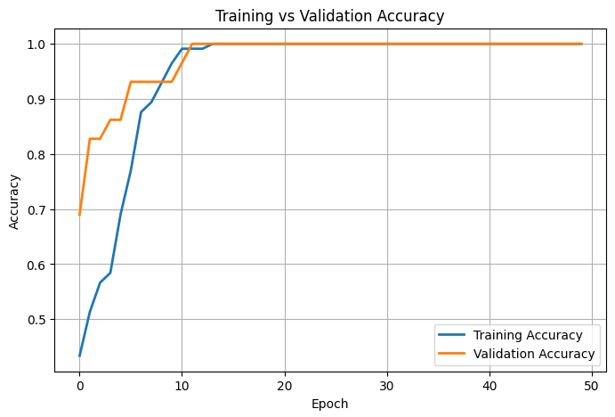
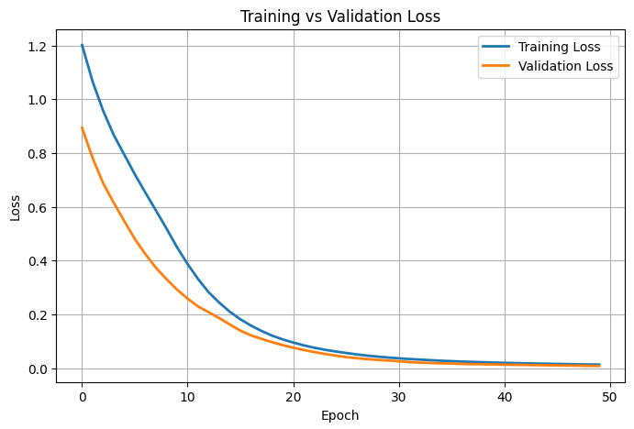
plt.grid(True) plt.show()

#training and validation loss graph plt.figure(figsize=(8,5))

plt.plot(history.history['loss'], label='Training Loss', linewidth=2)
plt.plot(history.history['val_loss'], label='Validation Loss', linewidth=2)

plt.title("Training vs Validation Loss") plt.xlabel("Epoch")
plt.ylabel("Loss") plt.legend()
plt.grid(True) plt.show()

#model evaluation
test_loss, test_accuracy = model.evaluate(X_test, y_test, verbose=0) print("Test Loss :", round(test_loss,4))
print("Test Accuracy :", round(test_accuracy*100,2), "%")

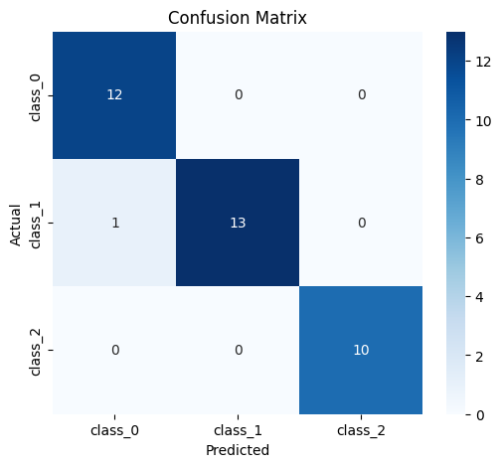
Test Loss : 0.1008
Test Accuracy : 97.22 %

#predictions

y_pred_prob = model.predict(X_test)

y_pred = np.argmax(y_pred_prob, axis=1)

print("Predictions Completed Successfully!")

2/2 ━━━━━━━━━━━━━━━━━━━━ 0s 82ms/step Predictions Completed Successfully!

#confusion matrix

cm = confusion_matrix(y_test, y_pred) plt.figure(figsize=(6,5))
sns.heatmap( cm,
annot=True, fmt="d",
cmap="Blues",
xticklabels=wine.target_names, yticklabels=wine.target_names
)

plt.xlabel("Predicted") plt.ylabel("Actual")
plt.title("Confusion Matrix") plt.show()

#classification report

print(classification_report( y_test,
y_pred,
target_names=wine.target_names
))

 | precision | recall | f1-score | support
class_0 | 0.92 | 1.00 | 0.96 | 12
class_1 | 1.00 | 0.93 | 0.96 | 14
class_2 | 1.00 | 1.00 | 1.00 | 10
accuracy |  |  | 0.97 | 36

macro avg | 0.97 | 0.98 | 0.97 | 36
weighted avg | 0.97 | 0.97 | 0.97 | 36

#learning rate comparison

learning_rates = [0.1, 0.01, 0.001] accuracies = []
for lr in learning_rates:

temp_model = Sequential([
Dense(32, activation='relu', input_shape=(13,)), Dense(16, activation='relu'),
Dense(3, activation='softmax')
])

temp_model.compile(
optimizer=Adam(learning_rate=lr),
loss='sparse_categorical_crossentropy', metrics=['accuracy']
)

temp_model.fit( X_train,
y_train,
epochs=50,
batch_size=16, verbose=0
)

loss, acc = temp_model.evaluate( X_test,
y_test, verbose=0
)
accuracies.append(acc*100) comparison_df = pd.DataFrame({
"Learning Rate": learning_rates, "Accuracy (%)": accuracies
})

comparison_df

Learning Rate | Accuracy (%)
0 0.100 | 97.222221
1 0.010 | 97.222221
2 0.001 | 100.000000

#Learning rate vs accuracy graph plt.figure(figsize=(10,6))
# Different colors for bars
colors = ['#FF6B6B', '#4ECDC4', '#45B7D1']

bars = plt.bar(
[str(lr) for lr in learning_rates], accuracies,
color=colors,
edgecolor='black', linewidth=1.5,
width=0.55
)

# Show accuracy value above each bar
for bar, acc in zip(bars, accuracies): plt.text(
bar.get_x() + bar.get_width()/2, acc + 0.3,
f"{acc:.2f}%",

ha='center', fontsize=11,
fontweight='bold'
)

plt.title(
"Effect of Learning Rate on Model Accuracy", fontsize=16,
fontweight='bold'
)

plt.xlabel(
"Learning Rate", fontsize=13,
fontweight='bold'
)

plt.ylabel(
"Accuracy (%)", fontsize=13,
fontweight='bold'
)

plt.ylim(min(accuracies)-2, 100)

plt.grid(axis='y', linestyle='--', alpha=0.6) plt.tight_layout()
plt.show()

#epoch comparison

epochs_list = [20,50,100] epoch_accuracy = []
for ep in epochs_list:

temp_model = Sequential([
Dense(32, activation='relu', input_shape=(13,)), Dense(16, activation='relu'),
Dense(3, activation='softmax')
])

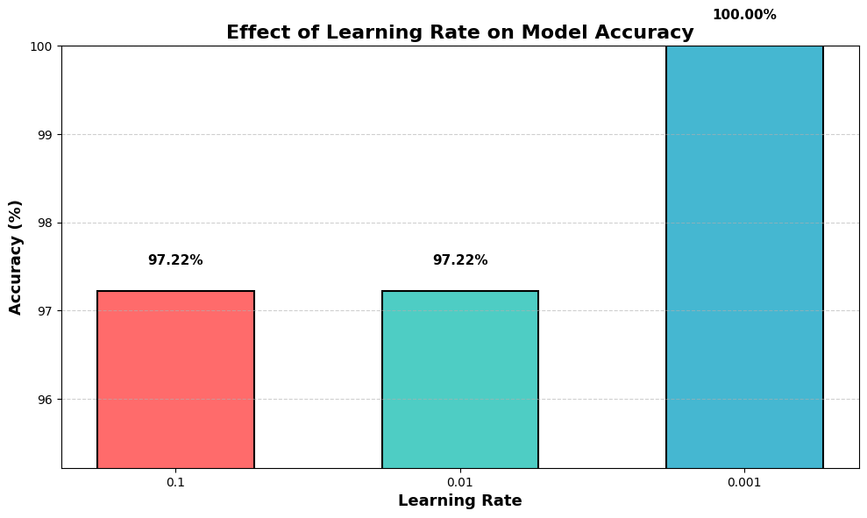

temp_model.compile(
optimizer=Adam(learning_rate=0.001),
loss='sparse_categorical_crossentropy', metrics=['accuracy']
)

temp_model.fit( X_train,
y_train, epochs=ep,
batch_size=16, verbose=0

